EAS550 DATA MODEL QUERY LANGUAGE
Team Members: Hema Priya Balaji, Manimegalai Mamallan, Sandeep Pudi
Project: E-commerce & Retail Analytics
Dataset Link: https://www.kaggle.com/datasets/olistbr/brazilian-ecommerce
QUERY PERFORMANCE TUNING REPORT
- Introduction:
This project emphasizes on upgrading the performance of the complex analytical SQL query used in the OLTP database. The query analyses the top product categories by revenue and review performance for the last six months joining the multiple tables (orders, order_items,products,product_categories,order_reviews).
The query chosen answers this question: Which seller generates the highest revenue and maintains good delivery performance and customer satisfaction?
This query is complex because of the following reasons:
- Joins four large tables (orders, order_items, order_reviews, seller)
- Performs aggregation such as sum and average
- Computes the derived metrics – revenue and delivery days
- Requires grouping and date processing
- Scans over 100,000 to 1,000,000+ rows, depending on join cardinality
The Olist dataset is highly relation, and it is large, optimizing such queries is important for the BI dashboards, seller performance reports and operations analytics.
- Original Analytical Query:
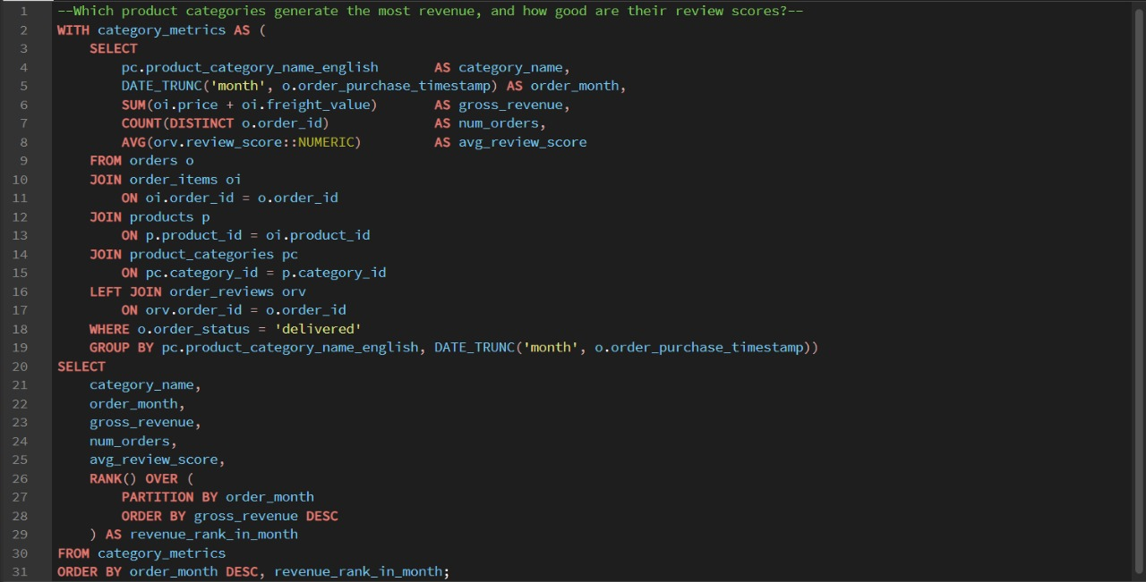

- Query Execution plan: Before Indexing
Key insights from EXPLAIN ANALYZE:
- Sequential scan on order_items around 1 million rows – PostgreSQL scanned the complete table which results in high cost.
- Hash joins between order_items and orders – There is no indexes that exist on join keys(order_id), PostgreSQL had to hash the tables that ends in slowing down.
- Hash join on sellers also is unindexed and the seller join was performed via hash join with full table scan.
- Large sort on GROUP BY seller_id that is by sorting millions of rows without supporting index which is expensive.
- Total runtime before the indexing is around 974.5 ms
Analysis:
The database performed several sequential scans and hash joins that cause high I/O and long execution time.
Before Indexing
Metric | Value (Before Indexing)
Execution Time | 974.509ms
Planning Time | 3.595ms
Query plan indication | Seq scan on orders, large hash join on order_item

- Indexing Strategy:
Optimizing the analytical query, we have added four targeted indexes:
- idx_orders_status_purchase_ts on orders(order_status, order_purchase_timestamp)
Purpose: Speed up the WHERE order_status = 'delivered' and date range filter on order_purchase_timestamp.
Effect: Allows PostgreSQL to use an index scan to directly access only delivered orders in the required time window instead of scanning the entire orders table.
- idx_order_items_product_id on order_items(product_id)
Purpose: Keep up the join order_items.product_id = products.product_id.
Effect: Enables index bitmap scans on order_items when resolving product related joins, reducing the cost of joining large order item data to the product dimension.
- idx_products_category_id on products(category_id)
Purpose: Aid the join for products.category_id = product_categories.category_id.
Effect: Makes the lookup of products by category more logical, therefore category level aggregations run faster.
- idx_order_reviews_order_id on order_reviews(order_id)
Purpose: Support the join order_reviews.order_id = orders.order_id.
Effect: Allows quick lookup of reviews per order via an index scan instead of scanning or hashing the entire order_reviews table.

- Query Execution Plan – After Indexing Strategy
After adding these indexes, the EXPLAIN ANALYZE plan depicts:
- The orders table is obtained through an Index Scan using idx_orders_status_purchase_ts, requesting both status and date filters at the index level, drastically decreasing the number of rows read.
- Joins linking orders, order_items, and products right now use index scans / bitmap index scans on order_items(product_id) and products(category_id) alternatively of full table scans, lowering I/O and CPU cost for those joins.
- The LEFT JOIN to order_reviews use an Index Scan on order_reviews(order_id), making improvement with analysis scores low cost.
- As a result, the total and window functions run on a smaller, pre filtered intermediate result, leading to a significantly lower total execution time (faster query with fewer scanned rows and fewer expensive hash operations).

- Performance Comparison:
Metric | Before | After
Execution Time | 974.509ms | 723.594ms
Planning Time | 3.595ms | 9.152ms
Seq Scans | High | Greatly Reduced
Join method | Mostly Hash Joins | Mostly Index Joins

- Summary:
The indexing strategy is applied in the above step and result is the major improvements to the query performance that enhances both operational and analytical workload and the improvement depicts:
- Better selection on the date filters
- Important reduction in the sequential scans
- Major efficiency in execution of window functions
- Faster multi-table joins
The optimized query is suitable for use in dashboard, APIs and reporting systems requiring near real time performance.

